

In a world where many people are more interested in talking than listening; in getting their point across rather than valuing the other person’s perspective; and in distracting themselves rather than interacting, listening is a lost skill. If you can demonstrate to your coaching client that you are really listening to what she is saying, you will answer a deep need and help her take a major step toward the clarity and purpose she seeks.

Some coaching and therapy models are built entirely on reflective listening. Reflective listening means that you pay close attention to what the client is saying and you reflect his communication to him so he becomes more aware of what he is saying, feeling, and intending.  This is a highly non-directive, client-centered approach, as it empowers the client to clarify where he stands, and discover or formulate the direction that works best for him.

Here are several levels of reflective listening:

**1.  Repeat verbatim.**

*Client:*“My son is doing poorly in school and I don’t know how to get him to improve his grades.”

*Coach:*“Your son is doing poorly in school and you don’t know how to get him to improve his grades.”

While this technique may seem simplistic, you will be amazed at how validated your client will feel to know that she is heard. If she is has not fully processed her experience, a simple reflection may bring significant insight. If your client feels that no one else in her life hears her, and you demonstrate that you do, you will be rendering a huge service.

**2.  Reflect the essence of the statement.**

*Client:* “I got to work late, my boss chewed me out, I had an argument with my coworker, and I lost an account.”

*Coach:* “So you had a pretty lousy day at work.”

In this situation you are bypassing the details of the client's story, and piercing to summarize the essence of his experience.

**3.  Reflect unspoken feelings.**

*Client:*“I found out that my boyfriend is exchanging lots of emails with his old girlfriend. I’m thinking about `breaking up with him.”

*Coach:*“It sounds like you’re pretty jealous and angry.”

Because much of our experience of life occurs at the feeling level, when you help a client get in touch with her feelings, you make headway toward working with her experience in a constructive way. Many clients are not in touch with their feelings, even though they have lots of them. Other clients have not been taught to express their feelings, or to suppress them, so they don't have a working vocabulary for their emotions. Assisting a client to become aware of her feelings and express them can constitute a major reward of a coaching session.

**4.  Reflect an unspoken choice or intention.**

*Client:* “I went to check out a graduate school, but when I couldn’t find a parking space, I turned around and came home.”

*Coach:* “I’m hearing that you are not highly motivated to attend this school.”

Many clients are dealing with the results of their intentions rather than recognizing the intentions that are fueling their experience and their actions. When you help a client get in touch with his underlying intentions, he can make a conscious choice about if he wants to act on them or choose intentions more compatible with his goals.

Note that in all cases, the coach does not attempt to analyze or steer the client in a direction. The coach is simply providing the client with a mirror of what she is saying or feeling.   
The coach is not trying to demonstrate expertise, figure things out for the client, or fix the situation. Each reflection is an offering to the client with the hope and intention that the coach’s statement will illuminate where the client stands, aid the client to gain self-awareness, and move ahead from there.

After you have offered the reflection, give the client an opportunity to say whether or not he resonates with what you have said. In most cases, he will. If not, ask the client how he would restate the reflection so it would be more accurate. Here you can see how the coaching session is a co-creation between the coach and the client.

To develop your reflective listening skills as a coach, practice in daily situations such as when your mother phones you; or your spouse tells you about his day at work; or in your conversation with your contractor. Every moment of practice will make you more effective with your clients.

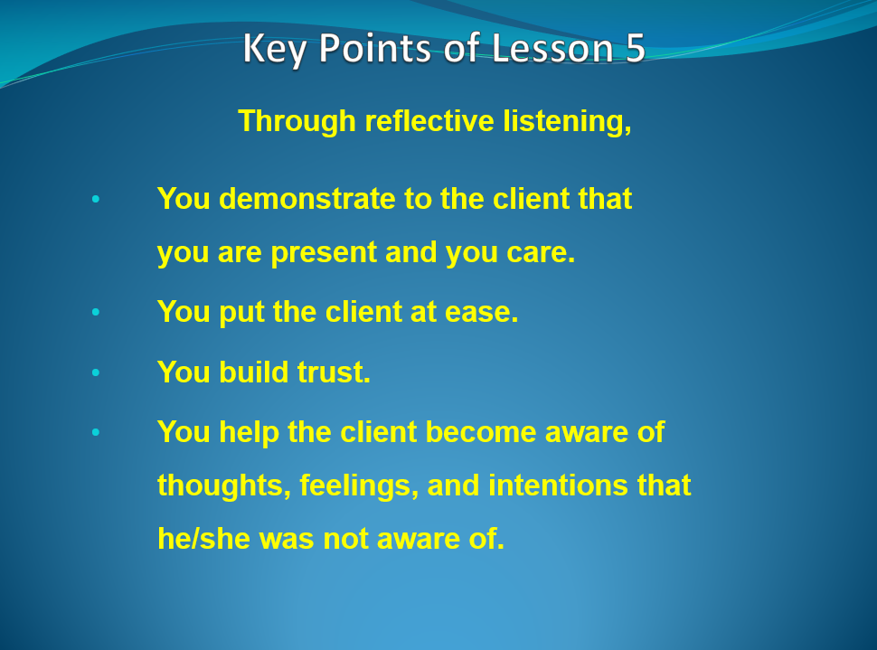

***Exercise:***

1. Repeat verbatim:

*Client:* "My brother and sister want to put our father in a nursing home, and I don't want to do it."

*Coach:*

2. Reflect the essence of the statement:

*Client:* "I finally found the courage to come out to my parents, and they were more supportive than I expected."

*Coach:*

3. Reflect unspoken feelings:

*Client:*"I want to attend a certain seminar, but my husband doesn't want me to. All he wants me to do is stay home with the kids."

*Coach:*

 4. Reflect an unspoken intention:

*Client:* "My ex-girlfriend keeps calling me. I told her not to call me anymore."

*Coach:*

***Affirm:***

**I pay close attention to what others say.  
  
 I let them know they are heard.  
  
Clients deepen in self-awareness because   
  
they see themselves more clearly through my reflection.**

The material in this lesson © Alan Cohen is proprietary for the education of students enrolled  
 in the Holistic Life Coach Training Program.  
 Copying or distributing for any other use is strictly prohibited.  
Thank you for your cooperation.